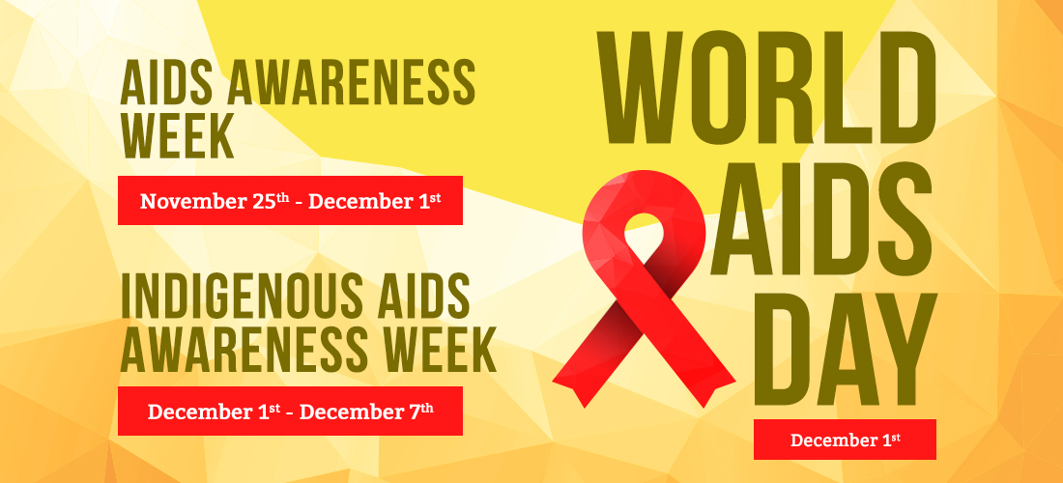

The STBBI Project, coordinated through the Saskatchewan Prevention Institute, would like to thank all of the organizations, groups, and communities that have shared their events with us. If events in your community are not listed, please check with your local organizations and health centers.

Prince Albert, SK
World AIDS Day Event  Tuesday, December 3  1:00 p.m. – 3:00 p.m. | Indian and Métis Friendship Centre - 1409 1st Avenue East  Host: SHA and Prince Albert & Métis Friendship Center  Event Details: Come together with us for a warm meal and a chance to learn about HIV/AIDS in a safe and welcoming environment. Take advantage of our HIV testing services and connect with local organizations sharing valuable information. Show your support by wearing a red ribbon, which will be available to all attendees.

Regina, SK
HIV Awareness and Testing  Monday, December 2  11:00 a.m. – 2:30 p.m. | mâmawêyatitân centre - 3355 6th Avenue  Host: SHA and 4 Directions Community Health Centre  Event Details: Join us for an Indigenous AIDS Awareness Day called “Knowledge Building”. This gathering will include mental health support, rapid testing, elder and smudging ceremony, local agency program information, a free lunch, and prizes.

North Battleford, SK
World AIDS Day & Testing Day  Tuesday, December 3  11:00 a.m. – 3:00 p.m. | Battlefords Indian & Métis Friendship Center - 960 103rd Street  Host: Battlefords Family Health Centre, Battle River Treaty 6 Health  Centre, BMIFC and SHA  Event Details: Take part in our World AIDS Day presentation with naloxone training, Health & Wellness and STBBI testing (last appointment 2:45pm). Plus, pizza and prizes! Follow-up testing on December 16 at Battlefords Sexual Health Clinic.

Kamsack, SK
HIV Awareness Day  Tuesday, December 3  10:00 a.m. – 3:00 p.m. | Stepping Stones Wellness Clinic 341 Stewart Street  Host: SHA  Event Details: Non-advertised awareness event for Opioid Agonist Therapy (OAT) clients and harm reduction clients. Interactive information booths on HIV and Take Home Naloxone.

